

Chess Moves
Problem #15 | Advanced | 20 Points

C programmers: your program name must be: prob15.exe
JAVA programmers: your program name must be prob15.class

Task (problem) Description:
Chess notation is a shorthand method of replaying a chess match move by move. To understand chess notation, consider an 8x8 chess board.
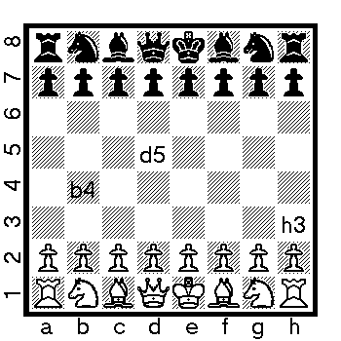

The rows are denoted by numbers 1-8 and the columns are denoted by letters a-h. To find the coordinates of a certain square, just look at the column letter and row number.

Each piece has a letter associated with it except the pawn. Its starting position(s) is also noted:
K = King (White=e1;Black=e8)
Q = Queen (White=d1;Black=d8)
B = bishop (White=c1,f1;Black=c8,f8)
N = knight (White=b1,g1;Black=b8,g8)
R = rook (White=a1,g1;Black=a8,g8)

White’s pawns are lined up on row 2 and black’s on row 7.

Every time you move, you write the letter for the piece that moved followed by the name of the square it moved to. For example, Ke2 or Qh5 or Bh8 or Nf6. No dashes; it’s that easy. For pawn moves you don’t write the “p”, just the destination square: e4, e5, h8. Remember: Capital letters are pieces, small letters files
When you capture with a piece, put an “x” between the name of the piece and capture square: Kxe2, Qxh5. When you capture something with a pawn, instead of putting the name of the piece on the left, you put the column (not the square) it came from, then the x and the square on which it captured. For example: dxe5 or hxg6.
Captures are NEVER implicit; they will always be denoted with an ‘x’.
When a pawn reaches the final rank it can be promoted to any other chess piece. Indicate the square and the promoted piece as follows: a8Q, c1N. Thus, the pawn at a8 is now a Queen, and the pawn at c1 becomes a knight.
There are other chess moves such as castling and capturing en-passant, but for the sake of this exercise, we will ignore them. You can also assume that if given Rg2 or Kh5 that only ONE Rook or Knight can legally move to the designated square.

Your program should accept a sequence of moves written in chess notation. At the end of the input your program will print an ASCII representation of the chess board at the current state of the game. Pieces should be noted by their color and rank. For example, a black knight would be BN and a white pawn is WP. White always moves first.

Program Input:
Your program should read input from a file named prob15.in

e4
e5
Nf3
d6
d4
Bg4
dxe5
Bxf3

Program Output:
Your program should output the state of the chess board to the screen. There should be exactly three spaces between each piece. Empty squares are donated by ‘xx’ (lowercase).

BR BN xx BQ BK BB BN BR
BP BP BP xx xx BP BP BP
xx xx xx BP xx xx xx xx
xx xx xx xx WP xx xx xx
xx xx xx xx WP xx xx xx
xx xx xx xx xx BB xx xx
WP WP WP xx xx WP WP WP
WR WN WB WQ WK WB xx WR

